CHAPTER ONE
INTRODUCTION
  - Background
A university is responsible for providing lecture theatres for students in various categories, irrespective of the faculty, or department.
Obafemi Awolowo University (OAU), Ile Ife, Nigeria is a government-owned and operated university which provides lecture rooms for all students in the university. The school comprises of faculties which includes; the faculty of art, administration, agriculture, education, environmental design and management, law, pharmacy, sciences, social sciences, technology, as well as the college of health sciences which comprises of the faculties of basic medical sciences, clinical sciences and dentistry.
Each of these faculties has some departments in them, except for law, pharmacy and dentistry with the mono-department structure. Each of the departments has lecture theatres built for receiving lectures for students of the department. Also, most of the faculties have a unique lecture theatre built mostly for the purpose of receiving lectures with large capacity of students.
However, in Obafemi Awolowo University, there are some lecture theatres not allocated to any particular department or faculty. They are used for some basic university courses being offered by all students, or almost all. Example of such courses are; Introduction to programming (CSC 201 and 202), as well as all the electives courses in the university. Such lecture theatres are referred to as the University lecture theatres.
At the beginning of every session, the University allocates lecture theatres for all courses and being offered by students and fixes the time frame for such lectures. Precedence is always given to courses with large capacity of students in occupying the bigger lecture theatres, as well as University courses as they are being allocated the University lecture theatres. Other courses are being allocated considering the departments or faculty offering the course. It must be noted that not all departments or faculties have enough lecture theatres, while some do not even have any at all. Hence, while allocating lecture theatres to different courses at the beginning of the semester by the University, considerations is always given to such courses as they are being allocated lecture theatres from other departments or faculties, since the time frame is monitored and does not clash with other lectures for the same venue, since no two lectures is not fixed at a particular venue at the same time.
  - Statement of the Problem
As it is presently on OAU campus, the University system allocates lecture theatres for courses without consulting the lecturers or the students involved, to ascertain if they are really convenient with the lecture theatres being allocated for their courses as well as the time frame selected for such courses.
The existing lecture theatre allocation system gives rise to a lot of alterations, as students and lecturers alike eventually choose not to use the venue being allocated by the University system, or choose to observe the lecture at another time, mostly not as categorically specified by the University system. This eventually leads to clashes in various lectures, as students and lecturers alike tend to find another venue, once such clashes occur. It has been a major cause for delay, and suspension of lectures just in the name of searching for venues. In addition to this is the problem of embarrassment, as lecturers sometimes argue over the rights over a particular venue whenever such clashes come up, this can really be an eyesore for the students when of course, such arguments most times happen in the class, while a lecture is going on.

  - Scope of the Study
This project is concerned with the development of a web application for Lecture theatres in OAU where every lecturer can always check the availability of a lecture theatre before going for a lecture at all.
Aim and Objectives
The aim of this project is to develop a web application for a lecture theatre management system. While the objectives to achieve this aim are to
- study and analyse the existing mode of allocation of lecture theatres in OAU.
- design a model to efficiently schedule lectures, and
- implement the model designed in (2)
  - Methodology
The methodology employed in this study was
A review was carried out to determine the available technologies and how well to approach the study
The unified modeling language (UML) was used to design the model, while the following software tools (html,css,sql,javascript, php) were used to implement the model.
  - Justification
This will eliminate the stress of both students and lecturers alike searching for venues. It will also eradicate the embarrassment of lecturers or students clashing in the same venue when receiving or about to receive a lecture.

1.7 Report Layout
In the remaining chapters of this study, we have the following;
Chapter two is basically on the review of the existing works carried out on the problem in software and in research area, the feature of the existing solutions and their drawbacks.
Chapter three describes the methodology, taking look into the problem and breaking it down into functional parts, and the design approach
In chapter four, the system requirements of the software, its implementation and the documentation are carried out.
Finally, chapter five presents the success achieved in the study, the limitations, areas for future development and the conclusion. This is immediately followed by references and appendices.

CHAPTER TWO

LITERATURE REVIEW

2.1 Preamble
A global revolution is and has been taking place in virtually every place in the world and every field of endeavor. It is driven by factors such as changing nature of work, the realities of the information age and new global partnerships, etc. The driving force of these factors is information and communication technology (ICT).

2.2 Information and Communication Technology (ICT)
The term Information and Communications Technology (ICT) encompasses a wide range of infrastructure, services, content and applications, from traditional telecommunications, the Internet, various media such as Radio & TV broadcasting to advanced Information Technology (IT) equipment and applications. It has shifted from naming the numerous technologies involved into a catch-all phrase encompassing as well all the communication and information applications and services enabled through the technologies. (African Connection, 2003).
The expansion of ICT is driving significant changes in many aspects of human endeavor throughout the world. At both microeconomic (individuals and firms) level and macroeconomic (national) level, ICT has increased the effectiveness and reach of development interventions, enhanced good governance and lowered the cost of delivering basic social services. According to Gudmund (2003), there has not been just one but five revolutions in ICT. However these revolutions are interdependent and they are discussed below.

2.2.1 Computer
The first revolution started during World War II, with the first large, automatic, general electromechanical calculator, Harvard Mark 1. A couple of years later, Electronic Numerical Integrator and Computer (ENIAC) was presented in Philadelphia, based on radio tubes and practically without any internal memory. Applications also were expanded, from use in academic research to weather forecasting, from airline ticketing to accounting. This development continues; the first ICT revolution is still under way.

2.2.2 Size and capacity of computers
The second ICT revolution has its roots in the 1970s, when the first “processors on a chip” and magnetic discs were constructed. This revolution has its roots in the first revolution as computers were developed in the first revolution however the size of the computer reduced the capability and capacity of computers increased. Hence, the advent of Personal Computers (PC). This second ICT revolution continues like the first: the size of computers decrease, the capacities of the computers increase, their applications expand, and the number of people who have access to them multiplies.

2.2.3 Microprocessor
The third ICT revolution is the development of microprocessors and the ability to embed them in an ever-widening range of products such as the steering systems of airplanes, the control panels of hydroelectric power stations, domestic air conditioning systems, traffic lights in our streets, to name but a few applications. Microprocessors constantly expand their capacity, applications and users (Freiberger, 2000).

    - Internet
The fourth ICT revolution stretches back to the late 1960s, when the U.S. Department of Defense drew up guidelines for a communication network among computers (ARPANET). After a while, universities in and outside the United States were hooked up to it, and some started to use it to send messages. France developed Minitel system, the U.S. National Science Foundation set up its own network among academic institutions that later became part of Internet. In Europe, EARN became a network among academic institutions, This fourth ICT revolution continues like the others as more and more computers are interlinked with an ever-growing number of “servers” and an expanding range of applications. Yet, another significant part of the fourth ICT revolution was its application versatility. Users of various disciplines and interests are able to adapt it to suit their variety of needs. (on the computer networks engineers had constructed, users built social networks to make them useful and effective).
2.2.5 Wireless links
The fifth ICT revolution was linking without cables—the new possibilities opened by mobile phones. Linking without cables now takes place not just intercontinentally via satellites, but also via high frequency short-range radio transmitters covering a specific area or cell (hence the name, “cellular phones”) and inside buildings by “Bluetooth” and infrared light.
2.3 Information System
Information system is a system, automated or manual, that comprises people , machines, and/or methods organized to collect, process, transmit, and disseminate data that represent user information.
Information system consists of three components, which are human, task and application system (Hirschheim, 1995). In this view, information is defined in terms of the three levels of semiotics.
Data, which can be automatically processed by the application system, corresponds to the syntax level. In the context, an individual that interprets the data that become the information constitutes the semantic level. Information then becomes knowledge when an individual knows (understands) and evaluates the information; which corresponds to the pragmatic level.
  - Web Applications Development
Web applications are applications whose functionality is processed on a web server, and is delivered to the end users over a network such as the internet or an intranet. The end users use a web browser to run web applications, which knows how to display and execute the data received from the server. In contrast, desktop applications are based on the entire operating system or a virtual machine which does most of the processing (Brinzarea et al., 2006)
A web application has to be made up of three layers:
- Content (HTML)
- Presentation (CSS)
- Behavior (Programming/Scripting)
According to Yank and Adams (2007), when building a web application, the following steps are considered
- Producing the content in HTML format. This is the base layer, which any visitor using any kind of browser should be able to view.
- Focusing on making the site look better, by adding a layer of presentation information using CSS. The site will now look good to users able to display CSS styles
- Lastly, using scripting to introduce an added layer of interactivity and dynamic behavior, which finally makes the site functional.

    - Web programming basics
Since the release of Netscape 2, browsers have included support for more than static HTML. They also have permitted web authors to include scripts in their pages. Scripts are basically small programs that can react to events occurring in the browser (e.g. the user clicking a link), or other factors (such as a change in the current date and time) by changing the web page in some way. Scripting languages can be distinguished from fully fledged programming in that they are used in small doses, for specific tasks and the domain usually does not exceed the browser (Lanridge,2005).
The following are categories of web technologies that enable websites to be dynamic.
- Client-side technology: The various client-side technologies differ in many ways, starting with the way they get loaded and executed by the web client. JavaScript is a scripting language, whose code is written in plain text and can be embedded into the HTML pages to enable the web client to do more interesting things than displaying static documents. JavaScript is supported by all modern web browsers without requiring users to install new components on the system. JavaScript is a language on its own right and it is supported by most web clients under any platform, and it has some object oriented capabilities. JavaScript is the widely embraced client-side scripting language in use today. In contrast to CGI programs and other server side technologies (PHP,ASP,etc.) that are run by a web server before a requested page is sent to the user’s web browser. This allows scripts to react to a richer set of events occurring in the browser without the overhead of having the browser contact the web server to ask what to do every time an event occurs (Brinzarea et al., 2006).
- Server-side technology: On the other hand, server-side scripting is done such that the scripts are executed on the web server and parsed into raw HTML before being served to the browser for rendering i.e. Server side technologies enable the server to store logic to build web pages on the fly. Examples of such technologies are Ruby, PHP, ASP, Perl etc.
Server-side technologies as explained by Langridge (2005) are similar to their client-side counterparts in that they allow the embedding of little programs into the HTML code and when executed, allow control of what appears in the browser window more flexible than just HTML. The difference is that unlike in Java (and other client-side technologies) where the code is executed within the browser after the page has been fully downloaded, the server-side scripts are executed by the web server before the page is sent to the browser and once interpreted, the result of the script will replace the server-side code.
It can thus be said that the development of powerful web applications involves the smart combination of HTML with both a server-side technology and a client-side technology.

    - The AMP architecture
The AMP architecture is used to describe the open source web development platform of Apache (as development and production web server), MySQL (as primary database design), ad PHP (as server-side scripting language). The development of any database-driven website on this architecture requires these core components as detailed below:

- Apache
Apache is an open source Web server. Its main use is to parse any file requested by any browser and display the correct results according to the code within that file. Apache is quite powerful and can accomplish virtually any task of a standard web server
The features and server capabilities of Apache includes the following:
- Password protected pages for multiple users
- Customized error pages
- Display of codes in numerous levels of HTML, and capability to determine at what level the browser can accept the content.
- Usage and error logs in multiple and customized formats
- Virtual hosting for different IP addresses mapped to the same server
- Directory index directives to multiple files
- URL rewriting with no fixed limit
Apache can be used to host a Web site for the general public, or for simply testing pages before they are uploaded to a secure server on another machine (Naramore et al.,2005).
- Mysql
MySQL is an open source Relational Database Management System which has most of the features of high-end commercial database servers, including the ability to manage very large quantities of data. It is designed to managing databases for web applications. According to Naramore et al (2005), it enables PHP and Apache to work together to access display data in a readable format to a browser. It is a Structured Query Language server designed for heavy loads and processing of complex queries.
Some of the features of MySQL as highlighted by Williams and Lane (2004) are as follows:
- Multiple CPUs usable through kernel threads
- Multi-platform operation
- Numerous column types cover virtually every type of data
- Group functions for mathematical calculations and sorting
- Function names that do not affect table or column names
- A password and user verification system for added security
- International error reporting usable in many different countries

MySQL is the perfect choice for providing data via the internet because of its ability to handle heavy loads and its advanced security measures (Naramore et al., 2005)
- Php
PHP is a recursive acronym that stands for Hypertext Preprocessor. It is an open source scripting language that is usually embedded or combined with the HTML of a web page. When the page is requested, the web server executes the PHP script and substitutes the result back into the page. PHP has many excellent libraries that provide fast, customized access to DBMSs, and it is an ideal tool for developing application logic in the middle tier of a three-tier application (Williams and Lane, 2004)
PHP is the most widely supported and used server-side web scripting language. There are many reasons according to (Naramore et al.,2005), that makes PHP a good choice;
- Open source: Community efforts to maintain and improve it are unconstrained by commercial imperatives
- Flexible for integration with HTML: One or more PHP scripts can be embedded into static HTML files and this makes client tier integration easy.
- Suited to complex projects: It is a fully featured object-oriented programming language, with more than 110b libraries of programming functions for tasks as diverse as mathematics, sorting, PDF documents, and sending email. There are over fifteen libraries for native, fast access to the database tier.
- Fast at running scripts: Using its built-in Zend scripting engine, PHP script execution is fast and all components run within the main memory space of PHP, thus it is faster than other popular scripting tools.

    - Merits Of web applications
Despite the act of trying to deliver functionality via the Web, the benefits of web applications when carefully developed, outweigh these experienced drawbacks. Brinzarea et al (2006) explains that even with the current issues of usability accessibility, web applications have acquired extraordinary popularity because they offer a number of major technological advantages over desktop applications as summarized below:
- Web applications are easy and inexpensive to deliver: With web applications, a company can reduce the cost of the IT department that is in charge of installing the software on the user’s machine. With web applications, all that users need is a computer with a working web browser and an internet or intranet connection.
- Web applications are easy and inexpensive to upgrade: Maintenance costs for software have always been significant. As for web application, as soon as the server machine is upgraded, everyone gets the new version.
- Web applications make it easier to have a central data store: When you have several locations that need access to the same data, having all that data stored in one place is much easier than having several databases in each location. This way, you avoid the potential data synchronization operations and lower security risks.

2.5 Obafemi Awolowo University
Obafemi Awolowo University, Nigeria is a government-owned and operated Nigerian university. The university is located in the ancient city of Ile-Ife, Nigeria. The university was founded in 1962 as the University of Ife, and was renamed Obafemi Awolowo University in May 1987 in honor of Chief Obafemi Awolowo (1909-1987); the first Nigerian premier of the Western Region of Nigeria who was also the University’s founding statesman and first Chancellor.
The motto of Obafemi Awolowo University “For Learning and Culture” is apt as the cosmogenic legend of the Yoruba describes Ile-Ife as the center of the world, ascribed in Yoruba mythology, the enviable role of being the site of the earth’s first solid ground in a watery primordial planet. The University has established a reputation for providing a unique and top quality liberal arts education that stretches its students beyond the bounds of their specific academic disciplines. The University takes pride in its well-rounded graduates who are making their mark in Nigeria as well as across the globe.
The alumni and faculty proudly describes Obafemi Awolowo University as “Great Ife”. The term is commonly accepted by others when they do not feel that their loyalty to their own alma mater is compromised.
Obafemi Awolowo University offers undergraduate and post-graduate programme in various fields of specialization spanning the humanities, the arts, the natural sciences, the social sciences ,the medical sciences, engineering and technology.
The University presently has 13 faculties, and two colleges –the Postgraduate College and the college of Health Sciences- administered in more than 60 departments.
The University owns its own VSAT access to the Internet and an Intranet. The University also has a fully computerized library. With these facilities, Obafemi Awolowo University is among the best research-oriented and industry focused universities on the African continent.
  - Existing Lecture Theatre Allocation System and Its Shortcomings
At the beginning of every session, the school authorities allocate lecture rooms for all the courses being offered by students in the university. One of the most important factors being considered before allocating a lecture theatre for a course is the class capacity of such course, the bigger lecture theatres are most times being reserved for the faculty courses, courses meant for various departments and electives. However, this lecture theatre allocation is always done manually, which gives room for a lot of mistakes and redundancy as one lecture theatre is being allocated for more than one course at a specific time. This leads to a lot of commotion as various lectures clash in the same venue, this leads to a lot of conflict between lecturers and students.
  - Proposed Lecture Theatre Allocation System
The proposed lecture theatre allocation system is aimed at a web based application for efficiently allocating lecture theatres for all courses at the beginning of every session. This will be done by collating all available lecture theatres in the university and then allocating them as appropriate, considering the size of each class in question.
  - Benefits
Having an online lecture theatre allocation system will definitely be a more refined method of allocation of lecture theatres. This would have solved the issue of redundancy as well as unnecessary repetitions. Since such system would be scalable, this would give room for addition and even removal of data in the system. This method would make it easier for the school authorities to engage in this exercise every session: since they now have a structure on ground, which only needs to be filed with the necessary information anytime there is a call for it, instead on doing the same thing over and over again, every session

CHAPTER THREE
METHODOLOGY

3.1 Introduction
This chapter deals with the methodology adopted in carrying out the study. A methodology is a collection of procedures, techniques, tools and documentation aids that helps system developers in their efforts to implement a new information system (Avison and Fitzgerald, 1995). A methodology consists of a number of components which include: how a project is to be taken into stages, what tasks are to be carried out in each stage, what output is to be produced, what constraints are to be applied, how the project should be managed and controlled, what support tools may be utilized and Rapid Application Development (RAD) is a software development methodology that involves building applications in a very short amount of time.. For the purpose of this project the Rapid Application Development (RAD) Model was used.

3.2 Rapid Application Development (RAD)
The RAD software model is a "high speed" adaptation of the water fall model in which rapid development is achieved by using a component-based construction approach. This methodology was chosen because it aids user-involvement in the design of the system, and thus reduces the possibilities of incorrect specifications. It was also chosen because it is cost-effective and encourages parallel project activities.
The choice of RAD is to speed up the development of the OAU lecture theatre allocation web application. Such environment demands continuous change with speedy creation and amendment of the information system to provide adequate support to this change. In this kind of scenario, the notion of RAD is obviously attractive.
The choice of RAD is due to its two primary advantages over other methodologies available. These are:
- increased speed of development: there is an increase to the development of the system due to the use of CASE tools whose goals is to have information about the requirements of the system and them turn them into usable code as quickly as possible. So, the use of RAD as our methodology would help to reduce the time spent in developing a new system, that is to say, short period of time is required to get a new workable version of the system when there is a change to the system needs.
- Increased quality: the speed increases are due to the use of CASE tools, the goal of which is to capture requirements and turn them into usable code as quickly as possible. Quality, as defined by RAD, is both the degree to which a delivered application meets the needs of users as well as the degree to which a delivered system has low maintenance costs. RAD increases quality through the involvement of the user in the analysis and design stages.

Phases of rapid application development (RAD)
- Requirement planning
- User design
- Construction
- Cutover

Requirement Planning
User Design
Construction
Cutover

Figure 3.1 Sequential order of the four phases that constitute the RAD approach.

(i) Requirements Planning
RAD requires that greater effort should be spent on the early stages of systems development. The main concern of this phase is the definition of requirements. For effective requirement planning two techniques must be involved, vis-à-vis: Joint Requirement Planning (JRP) and Joint Application Design (JAD). The two techniques are workshops or structured meetings. JRP seek to identify the high-level management requirements of the system at a strategic level. Students and lecturers of various faculties are the participants expected for this phase because, a clear vision understanding of the overall objectives as well as how it contribute to overall objectives of the system must be highlighted here. “JRP is a creative workshop that helps to identify priorities, to eliminate unnecessary functions and so on.” (Avison, 1997). Both the overall business knowledge and specific knowledge must be defined. So, if the right people are not involved the workshop should not take place. In light of this, all superior officers in charge of lecture theatre allocation or management are to participate in this exercise. This is important for decision-making purpose and for agreeing on the requirements in the shortest possible time.
In order to know the system requirements, data was collected about the existing system by conducting interviews and direct observation. Interviews with lecturers and administrators to study the existing system and possible ways of improving it were conducted .The following questions were asked during the interview:
- What is the total number of lecture theatres in each department?
- What is the number of departments in each faculty?
- How are courses being allocated into various lecture rooms?
- What are the criteria for selecting lecture theatres for particular courses?
- What are the shortcomings of the existing system?
- Are there envisaged problems of adopting this new system?
- How feasible is the new system
(ii) User design
RAD tools used at this stage include the CASE tools. The user design phase is developed using the following four diagramming techniques: entity modeling, functional decomposition, data flow diagramming and action diagrams. It is expected of the participant in the workshop to be familiar with these techniques, but getting the requirements as correct as possible to reflect the OAU lecture theatre allocation needs should be highly emphasized here. Therefore, the use of technical language commonly found in information systems should be avoided; instead language used in the workshop and expressed in diagrams is that of the needs of this study. Results from the user design phase are covered through the use of Integrated CASE tool that checks both internal consistency and that with other applications and corporate models. CASE tool enables the speedy, accurate and effective transfer of the results into the next phase which is the construction phase. The use of diagramming and case tools as well as prototyping tools to certain degree is specific to martin’s RAD methodology.
As said earlier, the use of Data Flow Diagram (DFD), entity model, functional decomposition, and action diagrams are indispensable tools for carrying out user design phase. DFD provides the key means of achieving one of the most important requirements of structured systems. That is, it enables a system to be partitioned or structured into independent units of a desirable size so that the system could be easily understood. Essentially, it consists of four elements: data flow represented by arrow (i.e. it specifies what flows), the process (i.e. how it flows), data store and source or sink.
The proposed OAU lecture theatre, web application system is broken down into some modules which include:

- Lecturer theatre allocation
- Student/Staff log in
- Student registration
- Addition and deletion of courses
- Addition and deletion of lecture theatre
- Information and updates
The Student registration module takes into consideration the registration details of every student in the university that can access the site. This module is involved in accepting users’ information, storing it in the database and enables such user into the site anytime to log in.
- Entity
An entity model that is equally of immense importance in user design stage .The basic building block of an ER model it describe a person, place, things, or event. (Chris et al. 2005).The following entities will be used in this design.
- Lecture theatre Records
- All courses Records
- Allocated lecture theatre Records
- Attributes
These are data elements that provide description and identity for entity instances. For this project work, the entities with their corresponding attributes are shown in Table 3.1.

Table 3.1: Attributes of the Database
LECTURE THEATRE RECORDS | ALL COURSES  RECORDS | ALLOCATED LECTURE THEATRE  RECORDS
Identity number | Course code | Date
Date | Course title | Identity Number
Lecture theatre_Name | Lecture theatre allocated | Lecture theatre name
Faculty | Department | Faculty
Department | Faculty | Department

Relationship
This defines associations between entities and allow for one entity to act on another. It is graphically represented as a line with an arrow, the arrow will go from one entity to another where the ‘from’ entity is the parent and the ‘to’ entity is the child (Chris et al. 2005).

iii) Construction phase
This phase occurs by taking the user design through to detailed design and code generation. The construction phase is by undertaken information systems professionals using a CASE tool such as IEF. During the construction phase in Martin’s RAD methodology there is the need to create series of prototypes that are then reviewed by the key users. This is achieved using an IE-based CASE tool. Thus the screens and designs of each activity such as forms for entering lecture theatre records with attributes like Date, Faculty, Department, Level, course title etc are prototyping and the users then approve them. If they do not give it any approval, they will request changes and the process goes on through a series if iterations. By prototyping and the use of CASE tool, these iterations are achieved quickly and testing is enabled. Construction is performed by only small teams consisting of three or four experts by using CASE tools. The small number of the team is to reduce the number of interfaces and interactions between people in the teams. These experts are known as SWAT (skilled with advanced tools) teams. The approach requires them to work quickly, making maximum possible use of re-usable designs that already exist. Once the detailed designs have been agreed, the code can be generated using the CASE tool and the system tested and approved. So, due to how construction works, there should not be any surprises to the users when they see the finished version. All associated documentation is then produced and database optimization being performed.

(iv) Cutover
The final phase of the system development is known as cutover. This is where the analyst carries out further comprehensive testing using realistic data in operational situations. This phase is also known for the training of users on the system, organizational changes, implied by the system, are implemented and finally the cutover is effected by running the old and the new systems in parallel until the old system is discarded. There is the use of evolutionary, or time box approach, to development and implementation. According to Avision and Fitzgerald (1997), it states that, “It recommends implementation of system in a 90 day life cycle. The objective is to have the easiest and most important 75 percent of system functionality produced in the first 90 day time box, and rest in subsequent time boxes. This forces users and developers to focus on only those aspects of the system that are necessary and probably most well-defined for development in the first time box. The benefit of this is that user requirements always evolve in different direction. That is their requirement may eventually change from that which has been envisaged. Another benefit is that it helps to focus on achieving an implementation in the specified period.
3.3 Unified Modeling Language (UML) Tools
UML tools have been employed to model the operation of this system. The Unified Modeling Language includes a set of graphic notation techniques to create visual models of object-oriented software- intensive systems. Examples of UML tools used for modeling a system include the activity diagram, use-case diagram, sequence diagram and class diagram.
Activity diagram describes the business and operational step by step work flows of components in a system. The activity diagram shows the overall flow of control.
Use case diagram describes the functionality provided by a system in terms of actors and their goals represented as use cases. This is shown in figure 3.2
Sequence diagram shows how objects communicate with each other in terms of sequence of messages. It also indicates the lifespan of objects relative to those messages. This is shown in figure 3.3

LOG IN
Check schedule
Check info
Lodge complaints
Create schedule
Add courses
Delete courses
Add courses
Edit schedule
<<uses>>
<<uses>>
<<Uses>>

Figure 3.2 Use case diagram of the system

USER: login
INFO:selectInfo
IT:gotoURLR
INFO:submitInfo
IT:printResult
gotoURL
Login
Select desired info
Submit request
printResult
Student
FIG 3:3 Sequence diagram of the system

CHAPTER FOUR
IMPLEMENTATION

4.1 Overview
This chapter discusses design and implementation of the Lecture Theatre Allocation Application for Obafemi Awolowo University. Students and lecturers alike are meant to access this application anytime via the web in the course of the semester. The system notifies them about the lecture theatres available in the university as well as all the courses that has been fixed for each of the lecture theatres for that semester, it also will display various information about each lecture theatre (if there is any), such information include the availability of a lecture theatre for that semester, or whether a particular lecture theatre has been restricted from public use due to renovations or other reasons. To consider implementation of the new system, certain factors have to be considered which are the requirements of the system to be designed, algorithms involved in the development of the application and a breakdown into segments of the developed application.

4.2 Requirements
Requirements for testing and implementation of the new system are the resources meant to be available before the system can be executed. Such resources are computer hardware components and computer software components which are further discussed in the next subsection.

4.2.1 Hardware requirements
As far as the hardware for running the system is concerned, the following parameters should be considered;
- Approximate number of users
- The number of other web services that should be provided.
Therefore, the following configuration is recommended;
a) Sever side
- A microcomputer with the following features;
Pentium 11 400MHZ or higher
256MB RAM or higher
20GB HDD or higher
Floppy Disk and CD Rom Drives
- A compatible monitor
- An enhanced keyboard and a mouse
- Printer
- A fast Network with internet connections
- High power rate uninterrupted power supply and an alternative power source.

b) Client side
Any computer with Internet connection.

4.2.2 Software requirement
a) Server Side
- Relational Database Management System: SQL database server
- Network Operating System like Window XP or Window 98.

b) Client Side
- Personal Computer Operating System, Preferably window series from Window 98
- Internet Browser (internet explorer)

4.3 Development Modules
Various modules were involved in carrying out this development and this comprises of the Student/Staff Login module, Student Registration module, lecture theatre allocation, addition and deletion of courses, addition and deletion of lecture theatres, information and updates, allocations view and reports. The various modules involved are visible from the home page shown in figure 4.1. and are further discussed below.

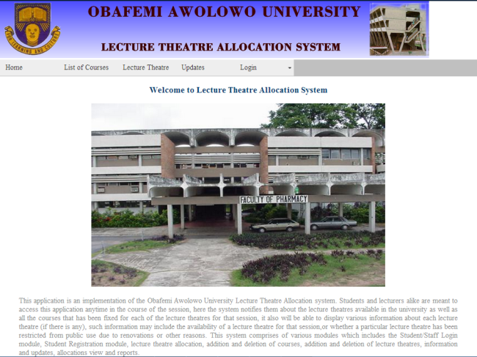

Figure 4.1: Screenshot of the home page of the system

The other modules are further discussed below:

4.3.1 Student/Staff login module
The Student/Staff Login Module is the module used to access the various section of the web application. For students, the log in enables them to check the lecture schedules with the corresponding lecture theatres allocated to them, as well as viewing of information and updates. For the staffs, the log in enables them similar privileges of the student as well as lodging of complaints to the admin anytime they have complaints about the allocation of venues/ time for their courses. Every student is given a unique username and password immediately he completes his registration. The figures 4.2 and 4.3 depict the typical login screen of the system.

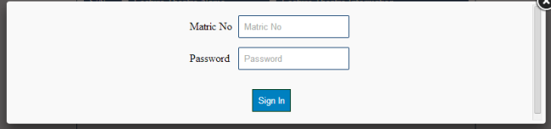
Figure 4.2: Screenshot of the student log in page

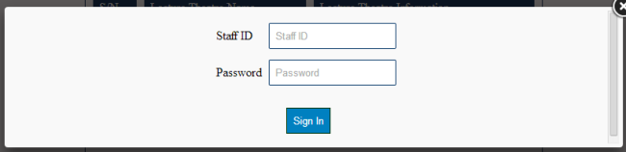
Figure 4.3: Screenshot of the staff log in page

4.3.2 Student registration module
The Student Registration module is used to enter Students Record entitled to viewing the information as not everybody without the relevant registration details will be allowed access into the site. Required records such as the Student username and password are entered into the system. Figure 4.4 shows the snapshot of the registration page after registration had been done and access granted.

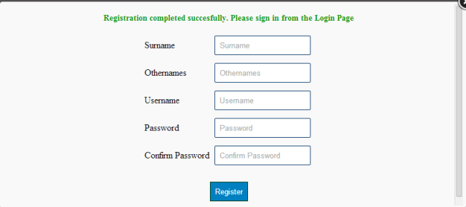
Figure 4.4: Screenshot of the registration page

4.3.3 Lecture theatre allocation
This module is where the admin allocates lecture theatres to various courses in the university. Five days is being considered (Mondays- Fridays) and for the time frame of 8am-6pm. In so doing, the same venue and time cannot be allocated for two courses, because once a course is fixed for a time and corresponding venue, it is being saved to the database immediately.

4.3.4 Addition and deletion of courses
This is where the admin deletes or adds courses to the existing number of courses in the database. It is assumed that various courses will be added to or deleted from the school curriculum from time to time. This module caters for such alterations. Figure 4.5 shows the addition of courses. This module also permits the admin to do some editing of course names and titles. Figure 4.6 shows the snapshot of the edit/delete courses page.

4.3.5 Addition and deletion of lecture theatres
This is where the admin deletes or add lecture theatre to the existing number in the database. It is assumed that some lecture theatres will be built with time, while some might be diverted to other uses, some might as well be undergoing some renovations for a particular session. This module caters for such complexities. Figure 4.7 shows the addition of lecture theatres. This module also permits the admin to do some editing of names of lecture theatres. Figure 4.8 shows the snapshot of the edit/delete lecture theatre page.
4.3.6 Information and updates
This is where various needed information will be displayed. Every registered student/staff can have access to this information. Such information may include; the unavailability of a particular lecture theatre throughout a session, or the availability of a lecture theatre after it had been declared unavailable for some time.
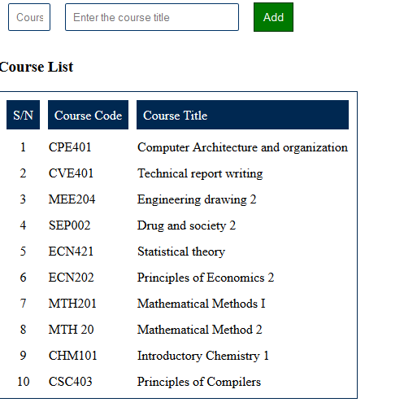
Figure 4.5: Screenshot of the addition of courses page
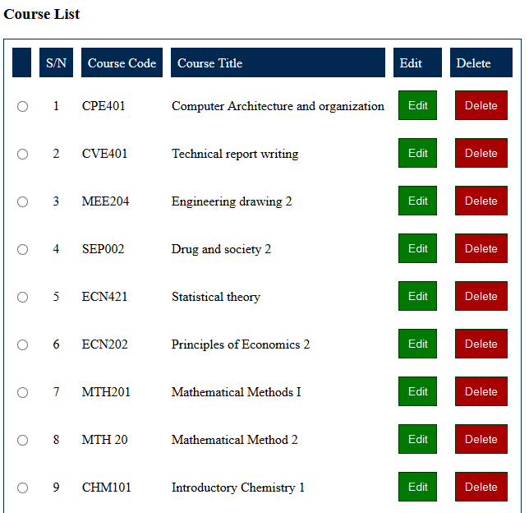
Figure 4.6: Screenshot of the edit/delete course page

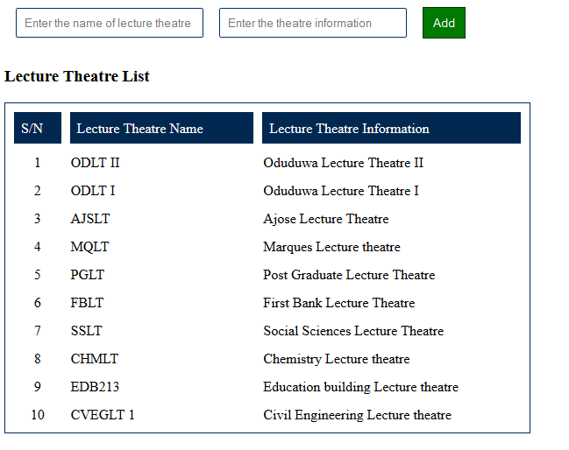
Figure 4.7: Screenshot of the addition of lecture theatres page

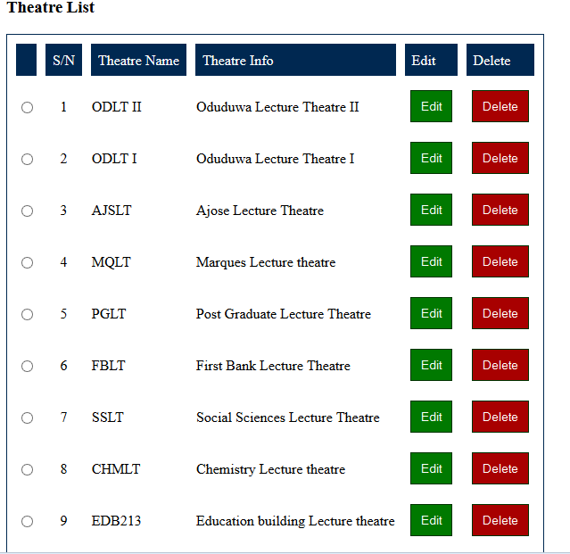
Figure 4.8: Screenshot of the edit/delete lecture theatre page

CHAPTER FIVE
CONCLUSION AND RECOMMENDATIONS

5.1 Conclusion
Introduction of a Computer Program for Obafemi Awolowo University lecture theatre allocation which allocates lecture theatres for courses offered in the school will in no little way make life easy for students, lecturers and the school administration at large. The allocation process is carried out by a computer program rather than human beings. The computer program ensures elimination of conflict in lecture theatres allocation and the embarrassment of two or more lecturers arguing about who owns which venue in the presence of the students. This system will eliminate or reduce the possibilities of error making in the allocation whereby some courses are allocated various venues, same venue and time allocated for several courses, or some courses not even allocated any venue at all. In addition, the school academic administrators are able to divert concentration to other functions rather than wasting their time for days to allocate lecture theatres and time for each course in the university, while students on the other hand could view the allocation of their courses from the convenience of their room, while class representatives will also be relieved of the laborious task of running around in trying to secure venues for various courses.

5.2 Recommendations
For effective implementation of this research work, it is recommended that the school administration collates total number of courses as well as the lecture theatres available for a session before resumption so that web administrators could enter such record on their system before school resumes.
Also, based on the conclusions above, it is hereby recommended that the implemented system which is the product of this research be put into use to realize its development objectives.

5.3 Future Research Work
A system that enables lecture theatres to be allocated based on the size of the class offering the course or the expected turnout of a recently added course in the university is recommended for future research work on this topic.

5.4 Challenges Encountered
In achieving the aim of this research work, some of challenges were encountered; which includes my inability to define the scope and limitations of the research on time. Various attempts were also made to get the manual existing lecture theatre allocation method from the school administration which was futile every time.

REFERENCES
Elizabeth Naramore (2005). Beginning PHP5, Apache and MySQL Web development.
Kevin Yank, Cameron Adams(2007). Simply Javascript Rakesh Vohra and Robert J. Weber 2000. A “Bids and offers” Approach to Package Bidding. Paper 2000
Sabah Al-Fedaghi (2011). International Journal of software Engineering and its applications vol. 5 No 2
African Connection (2003). “A African Connection: Centre for Strategic Planning: Rural ICT Toolkit for Africa”, Intelecon Consultancy Ltd,Vancouver. Draft 3, pg 4.
Austin (1996)"Information System Development: Methodologies, Techniques and Tools",2nd Edition ,Mc-GrawHill publishers company ,UK
DAVID E. Avison and Guy Fitzgerald (1997). Organizational background information for study
FAO Technical papers, (2000)
Ogedengbe, 0.Taiwo,AT Kamar,O.T, Adewunmi I.K (2005). Technical report writing
DAVID E. Avison and Guy Fitzgerald (1995). Information Systems Development: Methodologies, Techniques and tools.
Hernes, Gudmund (2003). Policy forum on planning for diversity: Education Multi-ethnic and Multi-cultural societies.
Avison D. and Fitzgerald G. (1995) “Information Systems Development: Methodologies,
Techniques and Tools.” Second Edition. McGraw-Hill International, Madenhead
Avison D.E (1997)."The 'Discipline' of information systems: Teaching, Research and pracice".In mingers and stowell, information systems: An emerging Discpline ? McGraw-Hill, Berkshire,pp 113-136.
Christopher .L, Brad .S, Greg .S. (1999) Database design on SQL server. Scottsdale, ARIZONA 85260.
Gray (1985),"Information systems Management in Practice", Prentice-Hall International,inc.1st Edition, USA, pp. 6-70.
Gudmund, H. (2003). “Emerging Trends in ICT and Challenges to Educational
Planning”. < www.SchoolNetAfrica.net>Accessed December 15 2013
Hirschheim, R., Klein, H. K. & Lyytinen, Varu, N. K. Information systems development and data modeling: Conceptual and philosophical foundations. Cambridge & Aston University Press, 1995.

APPENDIX Source Code Listing
INDEX.PHP
<?php
require_once('include/config.php');
require_once('include/function.php');
require_once('include/session.php');
confirmed_logged_in();
?>
<!DOCTYPE html PUBLIC "-//W3C//DTD XHTML 1.0 Transitional//EN" "http://www.w3.org/TR/xhtml1/DTD/xhtml1-transitional.dtd">
<html xmlns="http://www.w3.org/1999/xhtml">
<head>
<meta http-equiv="Content-Type" content="text/html; charset=utf-8" />
<link rel="stylesheet" href="css/style.css" />
<link href="SpryAssets/SpryMenuBarHorizontal.css" rel="stylesheet" type="text/css" />
<title>Welcome to Theatre Allocation System</title>
<script src="SpryAssets/SpryMenuBar.js" type="text/javascript"></script>
<script type="text/javascript" src="js/jquery.min.js"></script>
<script type="text/javascript" src="source/jquery.fancybox.js"></script>
<link rel="stylesheet" type="text/css" href="source/jquery.fancybox.css" media="screen" />
<script type="text/javascript">
$(document).ready(function(e) {
$("#fancybox-manual-b").click(function() {
$.fancybox.open({
href : 'studentlogin.php',
type : 'iframe',
padding : 5
});
});
$("#fancybox-manual-a").click(function() {
$.fancybox.open({
href : 'stafflogin.php',
type : 'iframe',
padding : 5
});
});
$("#fancybox-manual-c").click(function() {
$.fancybox.open({
href : 'register.php',
type : 'iframe',
padding : 5
});
});
})
</script>
<script src="SpryAssets/SpryMenuBar.js" type="text/javascript"></script>
<script type="text/javascript">
var i = 0;
var image = new Array();
// LIST OF IMAGES
image[0] = "images/image1.jpg";
image[1] = "images/image2.jpg";
image[2] = "images/image3.jpg";
image[3] = "images/image4.jpg";
image[4] = "images/image5.jpg";
image[5] = "images/image7.jpg";
image[6] = "images/image8.jpg";
var k = image.length-1;
var caption = new Array();
// LIST OF CAPTİONS
caption[0] = "Caption for the first image";
caption[1] = "Caption for the second image";
caption[2] = "Caption for the third image";
function swapImage(){
var el = document.getElementsByClassName("body");
el.innerHTML=caption[i];
var img= document.getElementById("slide");
img.src= image[i];
if(i < k ) { i++;}
else { i = 0; }
setTimeout("swapImage()",3000);
}
function addLoadEvent(func) {
var oldonload = window.onload;
if (typeof window.onload != 'function') {
window.onload = func;
} else {
window.onload = function() {
if (oldonload) {
oldonload();
}
func();
}
}
}
addLoadEvent(function() {
swapImage();
});
</script>
</head>
<body>
<div class="container">
<div class="header"><img src="images/PROEJCT BANNER.fw.png" width="100%" /> </div>
<div class="menu">
<ul id="MenuBar1" class="MenuBarHorizontal">
<li><a href="#">Home</a> </li>
<li><a href="listcourses.php">List of Courses</a></li>
<li><a href="Lecturetheatre.php">Lecture Theatre</a></li>
<li><a href="allocation.php"> Allocation</a></li>
<li><a href="updates.php">Updates</a></li>
<li><a href="" class="MenuBarItemSubmenu">Login</a>
<ul>
<li><a id="fancybox-manual-a" href="#">Staff Login</a></li>
<li><a id="fancybox-manual-b" href="#">Student Login</a></li>
</ul>
</li>
<li><a id="fancybox-manual-c" href="#">Register</a></li>
</ul>
</div>
<div class="mainbody">
<h3 align="center">Welcome to Lecture Theatre Allocation System</h3>
<div class="body" align="center"> <img name="slide" id="slide" height="400" width="640" src="images/image1.jpg" /> </div>
</div>
<div class="wordings">This application is an implementation of the Obafemi Awolowo University Lecture Theatre Allocation system. Students and lecturers alike are meant to access this application anytime in the course of the session, here the system notifies them about the lecture theatres available in the university as well as all the courses that has been fixed for each of the lecture theatres for that session, it also will be able to display various information about each lecture theatre (if there is any), such information may include the availability of a lecture theatre for that session,or whether a particular lecture theatre has been restricted from public use due to renovations or other reasons.
This system comprises of various modules which includes the Student/Staff Login module, Student Registration module, lecture theatre allocation, addition and deletion of courses, addition and deletion of lecture theatres, information and updates, allocations view and reports. </div>
<div class="footer"></div>
</div>
<script type="text/javascript">
var MenuBar1 = new Spry.Widget.MenuBar("MenuBar1", {imgDown:"SpryAssets/SpryMenuBarDownHover.gif", imgRight:"SpryAssets/SpryMenuBarRightHover.gif"});
</script>
</body>
</html>
<?php
mysql_close($connection);
?

